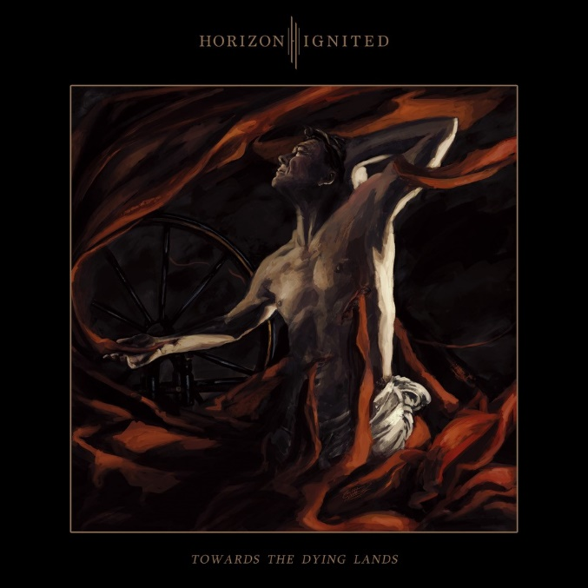

**HORIZON IGNITED**

**«Towards The Dying Land«**

##### OUT: July 1st, 2022

|  |  |
| --- | --- |
| **Line up:** | **HORIZON IGNITED online:** |
| Okko Solanterä | Vocals  Johannes Mäkinen | Guitar  Vili Vottonen | Guitar  Miska Ek | Keyboards  Jukka Haarala | Bass  Jiri Vanhatalo | Drums | [facebook.com/HorizonIgnited/](http://www.facebook.com/HorizonIgnited/)  [twitter.com/HorizonIgnited](https://twitter.com/HorizonIgnited)  [instagram.com/horizonignited](https://instagram.com/horizonignited) |

The gloomy, tenacious and energetic heart of melodic death metal began pulsating in the early 1990s − and it hasn’t stopped beating since.

Over the past thirty frantic years, this passion-raising heavy metal subgenre has undeniably evolved and changed, but some complaints have also been heard in the dim alleys: where are all the magnificent entrants?

Well, as so many times before, kindly turn your face towards Finland − still the most metallic country in the world − and meet melodic death metal's hottest newcomers... **HORIZON IGNITED** has arrived and this relentless sextet is here to stay!

"Our roots date back to 2017, when **Vili Vottonen** and myself took over the guitar duties of the new ensemble", opens **Johannes Mäkinen**.

"Before long drummer **Jiri Vanhatalo** and keyboardist **Miska Ek** joined our relentless mob. Finding an expressive and powerful singer was a bit more challenging but luckily **Okko Solanterä** was eventually found through mutual friends. When bassist **Jukka Haarala** finally got on board, all the necessary parts of the puzzle had found their places... And as you might guess, we no longer wasted time but lifted a storm off the horizon!"

The debut album "**After the Storm**" was unleashed when the northern winds choked **HORIZON IGNITED**'s hometown of Kouvola in early 2019.

"We’re still proud of the first record − it represents those times rather well − even though the band has progressed tremendously since then", nods **Mäkinen**.

"Considering "**After the Storm**" was a completely self-published album where everything was done without any external help, the success of the record for example on Spotify surprised us completely. We literally climbed from zero to nearly one hundred thousand monthly listeners within a very short period of time!"

**HORIZON IGNITED**'s diverse class of act − captivating and guitar-driven melodic death metal flavored with catchy metalcore elements among others − also caught the attention of renowned German record label **Nuclear Blast**.

"Things started rolling when we started co-operation with Hard Impact Management. A bit later they were in contact with a representative of **Nuclear Blast**, and... Well, the rest is a heavy metal history, as they say", laughs the singer.

The history of heavy metal is indeed being made here, and that slaying work of art is entitled "**Towards the Dying Lands**". It is **HORIZON IGNITED**’s second full-length assault − an unprecedented musical journey through deep valleys, high hills and dark forests.

"We wrote and recorded "**Towards the Dying Lands**" exactly on our own schedule, and there was no hurry of any kind. The goal, of course, was to manufacture a dynamic album of the highest quality modern metal possible, both in terms of composing and production", ponders **Solanterä**.

"And of course in terms of the words... **HORIZON IGNITED**'s lyrics are really widespread. Some stories are based on harsh reality − suicidal thoughts, agonising depression and so on −, while some other songs reflect fictional stories from epic movies or mythological books. Social and religious criticism is also involved."

As for **HORIZON IGNITED**'s new album as a whole, there is no need to quell the flood of praise. Shall we start for example with crushing riffs, insightful melodies, dynamic production or something else?

"The album's title track was born at the beginning of the process, and it underlined to us that something great was looming under the surface. This rather contagious song, which is also the first single, gives some serious hints about what's in store for the rest of the album", states **Mäkinen**.

"Oh, the greatness of the track is crowned by the divine guest guitar solo by our friend Markus Vanhala (Insomnium, Omnium Gatherum)!"

If the new album's title track uncompromisingly reveals **HORIZON IGNITED**'s ability to write first-class melodic death metal, the record's closing number underscores the band's fearlessness of bringing new flavours on the table.

""Eventide of Abysmal Grief" is the most dynamic and melancholic song we have done − so far. We proudly play melodic death metal, but you can expect experiments from us in the future as well", promises the guitarist.

What is the biggest goal of the band?

"We are going to take new steps all the time and keep ourselves hungry! Just as an example: we will

be going on a major European tour later this year as an opening act for a couple of other long-lived bands. But it is not supposed to end there... Of course we will do our own headlining tour one day", muses **Solanterä**.

"Why should the goals be left too low? Hell no! So let's conclude this by saying that **HORIZON IGNITED** would like to be the first band to perform on the surface of the moon... Hah hah!"